Md. Shakil Ahmed

Roll-2013

Case-01

**For Image -01**

Answer-01:



Answer-02:

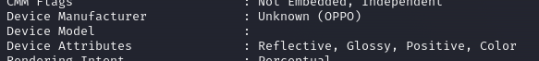

Answer-03: 

Answer-04:



Answer-05: 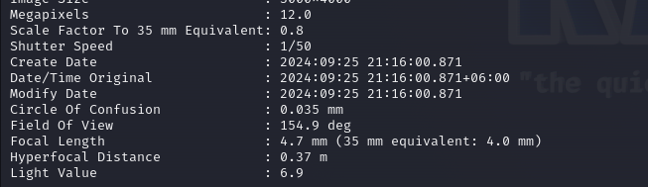

**For Image -02**

Answer-01:



Answer-02:



Answer-03: 

Answer-04:



Answer-05: 